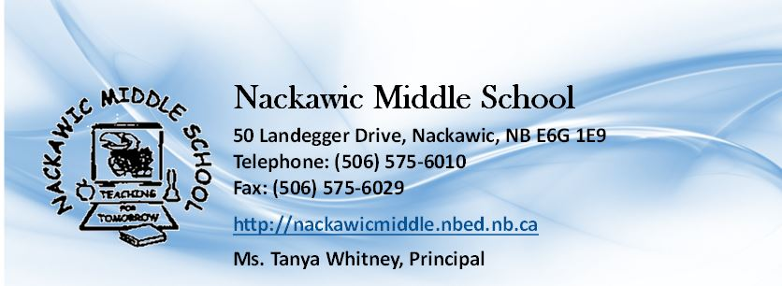

Student Handbook
2020- 2021

Nackawic Middle School
50 Landegger Drive
Nackawic, NB
E6G 1E9

Tel: (506) 575-6010
Fax: (506) 575- 6029

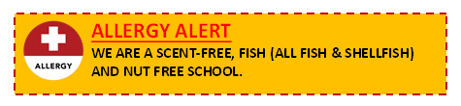
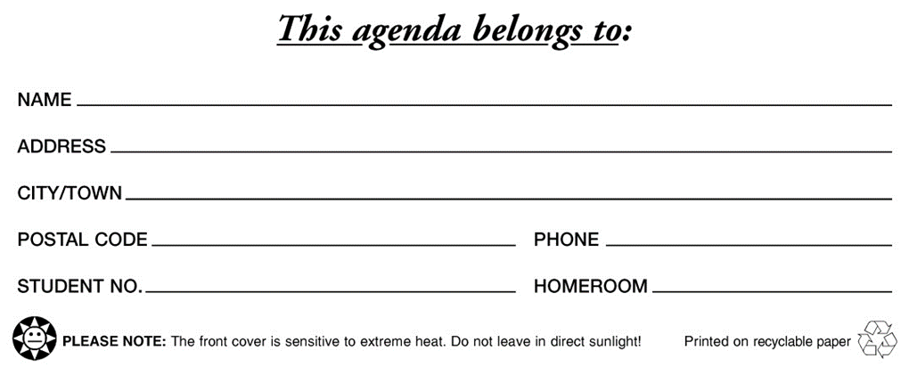
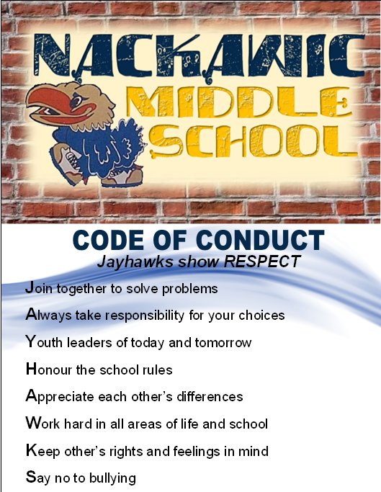

MESSAGE TO PARENTS

The staff of Nackawic Middle School believes your child’s education is of prime importance. You are welcome to visit the school at any time. We know that parents are our partners in education. Regular communication with your child’s teacher will keep you informed of any problems as well as successes. School wide information will also be shared in a variety of ways, via voice mail messages and the school webpage, and occasional newsletters. Please consult our webpage on a regular basis for updates:
nackawicmiddle@nbed.nb.ca

CLOSED CAMPUS
Nackawic Middle School is a closed campus. Students are expected to remain on school property while under our care. Medical appointments and other special situations for leaving during school hours will require a written parental excuse and parental pick up. All students must report to the office when leaving for such appointments and must report again upon their return.

DRESS-DOWN FRIDAYS
Each Friday, students are permitted to wear their hats during the day provided they pay 25¢. Staff members are permitted to dress casually.

BUS PASSES
Grade 6 students will have one primary and one secondary bus stop. These stops will be recorded on the student’s data collection sheet sent home in September. In case of a student emergency only, the principal may approve an alternate bus stop. Otherwise, requests for students to travel on an alternate bus cannot be approved. Bus changes will not be accepted by telephone.

CAFETERIA
*The school district will be assessing cafeteria services provided for the 2020-21 school year, due to pandemic restrictions*

ACTIVITY NIGHTS
*Activity nights will be assessed and offered only as able during the 2020-21 school year based on restrictions during current pandemic status* Typically, Activity Nights are have been held on Thursdays throughout the school year. We will notify parents via our newsletter and/or voice messaging system prior to each event.
The time for each activity evening is 6:30 – 8:30 pm. Parents are reminded that it is important to arrive on time to pick up their child for the activity evenings.

PLAYGROUND RULES
*Further restrictions and boundaries will be established to follow pandemic protocols of physical distancing and communicated to families*

Boundaries: Students are to stay within the following areas when playing/socializing outside during noon hour:
- The front of the school (to the front edge of the parking lot)
- The basketball court (the area outlined on the pavement)
- The right side of the school (including the ball field, but excluding the soccer field)

Out of Bounds: Students are prohibited from playing/socializing in the following areas outside during noon hour:
- All wooded areas
- The soccer field
- The parking lot/parked cars
- The grass median between the middle school and the high school
- The right side of the school building
- The rear of the school building

LOCK AND LOCKERS
Lockers and locks (school lock only) are assigned by homeroom teachers. All personal items should be stored in lockers, with nothing being placed on top. Lockers are to be kept clean; they are the property of the school and may be inspected by the administration at any time. Students will be charged $5.00 for a lock not turned back in at the end of the school year.

STUDENT FEES
Student fees are $35 per student. This fee helps cover costs of the following:
Consumables for exploratory programs (which includes a $5 exploratory fee), school agenda, lock for lockers, student materials, and other education purposes as deemed fit by the school principal.

Student fees are due by September 30th. Fees are able to be paid with cash, cheque or online at https://anglophonewest.schoolcashonline.com.

EXTRA CURRICULAR FEE (sports only)
This fee will help pay for officials and playing costs. Fees are as follows:
Badminton $30
Soccer $40
Volleyball $40
Basketball $55
Track & Field $10
Cross Country $10

SCHOOL TEXTBOOKS
Textbooks are loaned free of charge to students for their use. All textbooks are to be returned at the end of the year, or earlier if the student leaves the school. Students who lose, tear or otherwise damage school books beyond normal usage will be required to pay the cost of replacement.

3. Follow expectations for proper behavior. We want students to feel safe at school and to enjoy learning. This means that no student has the right to disrupt a classroom in any way.

Teachers are responsible for establishing fair and reasonable classroom rules and will engage students in creating and understanding these expectations. These will be clearly outlined at the beginning of the school year. Teachers will communicate with parents and attempt to resolve problems. All communication and interventions will be documented.

4. Treat staff and peers with courtesy and respect. Inappropriate language will not be tolerated.

5. Individuals should refrain from close personal contact. The focus of school is on safe respectful spaces and intimate physical closeness is inappropriate.

6. A safe school means no fighting. This includes playground, bus, and other events that involve our students. Consequences for fighting will be determined by administration. Repeat offenses could result in more serious consequences.

7. Clothing. Nackawic Middle School promotes a respectful environment for all students and staff. Our expectation is that students are dressed in a way that is respectful and in no way displays messaging that is offensive to our school community.

STUDENT RECOGNITION
Students are recognized in several ways throughout the year:
Monthly School-Wide Assemblies – will be held on the last Thursday of each month at which time we will recognize students’ achievements in the following areas; academics, sports, birthdays and community involvement, to name a few.
- Student of the Month – Criteria for recipients will be based on excellence, respect, responsibility and safety.
- Monthly Male and Female Athletes – are chosen by our Physical Education Department and sponsored by Ryan’s Pharmacy. Recipients’ photos are posted monthly on the Phys. Ed bulletin board located at the gym entrance and at Ryan’s Pharmacy.
- Annual Sports, Academic and other Achievement Awards – will be presented at an “Awards Assembly” to be held in June.
- Student Body Award – students who display strength of character and make positive choices.

STUDENT BEHAVIOUR
1. Attend classes on a regular basis. Daily attendance is recorded at the office following morning announcements. Late arrivals must report to the office and sign in. The homeroom teacher will handle attendance issues, and will require a written note for all absences. Both homeroom teachers and administration will collaborate on supporting attendance plans for students.
2. Be prepared for class and complete assigned work.

8. NMS Cell Phone and other Electronic Devices Policy. Electronic devices include: cell phones, camera phones, IPods, or any such other electronic communication or internet accessing device. The most important focus of school is learning and safety and any authorized use of technology by students will respect this. Any use or presence of devices that interfere with learning or safety will be addressed and students may be required to keep devices in lockers if the situation or expectation warrants. This will be determined collaboratively with staff to determine the most appropriate use of technology. Parents will be informed of the school’s expectations as well as be informed of any concerns that arise with your child.

9. Respectful and violence free environment. The school will clearly promote and uphold the expectations of Policy 703 “Positive Learning and Work Environment” for all staff, students and visitors to our building. We expect that we all will work towards maintaining an environment that is safe from physical, mental, social, and sexual harassment and violence. When conflict arises, it will be addressed in a manner that respects due process and always puts safety as our number one priority. Families can expect to be engaged in planning and responding to incidents that involve your children.

https://www2.snb.ca/content/dam/gnb/Departments/ed/pdf/K12/policies-politiques/e/703A.pdf

